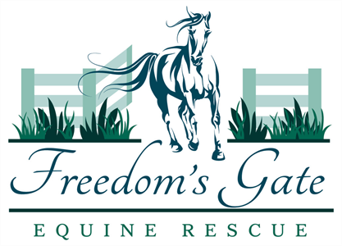
Adoption Application
APPLICANT INFORMATION
Name: ___________________________________
Address: __________________________________________________
City: _____________________, Province: _______
Phone Numbers:
Home: ___________________________
Cell: ____________________________
Email: ________________________________
HORSE:
ONE: Gender:
Are you interested in adopting:
- a mare B) a gelding C) no preference

TWO: What age of horse are you most interested in?
___________________________________________
THREE: Has a particular horse we have available for adoption caught your eye?
_________________________________________________
FOUR: Would you be willing to adopt a horse that is injured or has been abused?
- Yes B) Maybe C) No
FIVE: Intended use for the horse:
_________________________________________________________
_________________________________________________________
SIX: Will you have help training your new horse?
A) Yes B) No
If so please provide the contact information of the friend, family member or trainer who will help you:
Name: ________________________________________
Address: ______________________________________
Phone number(s): _______________________________
EQUINE EXPERIENCE
EIGHT: Do you currently own any horses or have you owned horses in the past?
A) Yes, I currently have horse(s) B) I have never owned a horse
C) I have owned horses in the past but do not currently have any.
NINE: In the past five years, have you given away or sold any horses? If so, please explain:
______________________________________________________
_______________________________________________________
TEN: Where will your horse be housed?
Address: _______________________________________________
City: ________________________________________
Province: ____________________
Is this a boarding facility? ________
If so please provide contact information:
Manager/Owner’s name: _____________________________________
Phone: ___________________________
EQUINE CARE – MEDICAL & NUTRITIONAL
Who is your veterinarian? _________________________________________________
Who is your farrier? _____________________________________________________
DECLARATION
I wish to apply for the adoption of a horse through Freedom’s Gate Equine Rescue, and hereby grant my permission to contact the above references, and to proceed with the processing of this application.
Applicant’s signature: ______________________________
Date signed: _______________
Please use this section for anything else you would like to tell us about you, or your family and pets.

